Alex Arnold
Professor Torres
2-25-25
IT 0115-41197
Lab 5

Part A:Netlabve3 740-742 for both Part A and BLinks to an external site.
Log onto Netlabs and utilize 70-242 below labs as a guide:

Lab Guide: Install_configure_domain_controller
Lab Guide: Create and Configure Users, Groups, and Organizational Units
Lab Guide: Advanced_AD
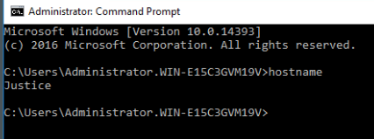
Rename DCB to Justice
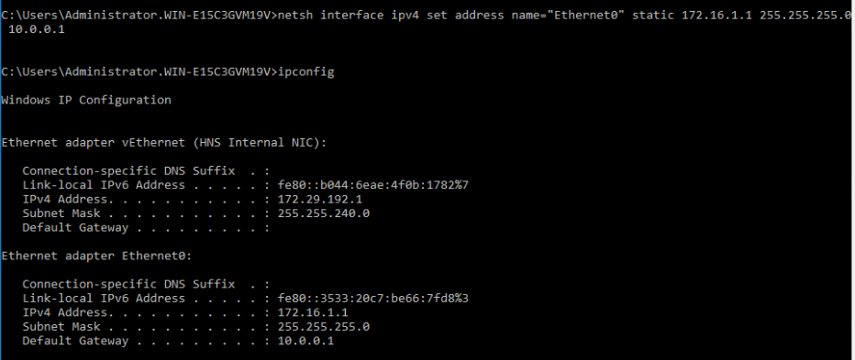
Change IP of Justice to 172.16.1.2/24

Setup DCB as a Domain Controller (install AD and promote to DC)
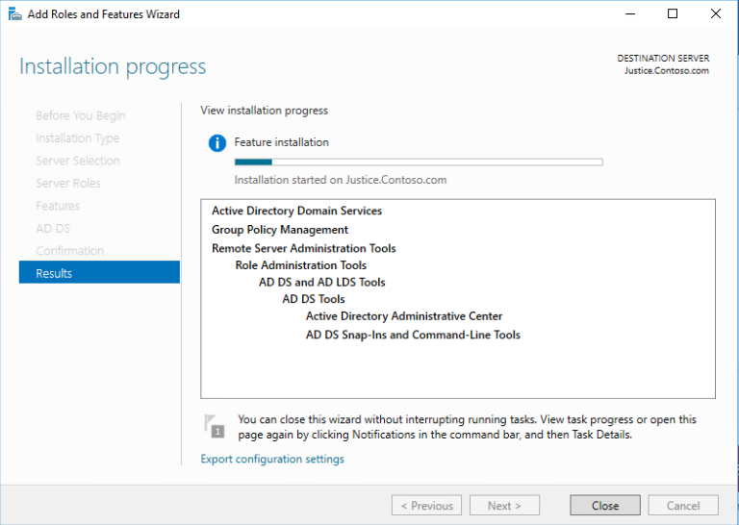
Install AD
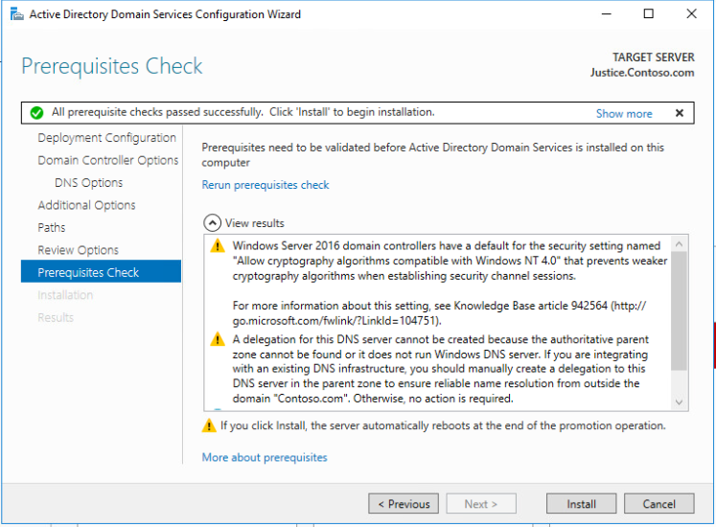
Promote to DC
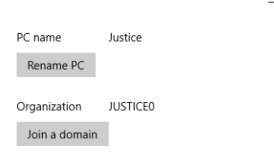
Domian name Justice
Add the following users to your new domain:
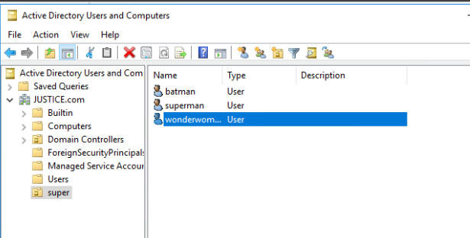
Superman and batman added
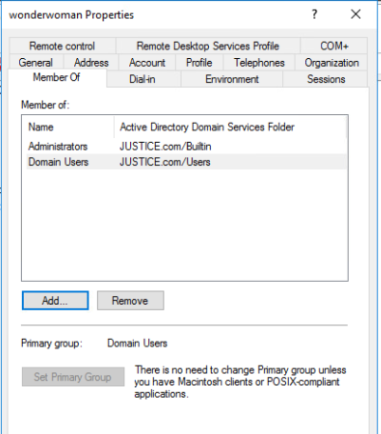
wonderwoman (make this user admin)
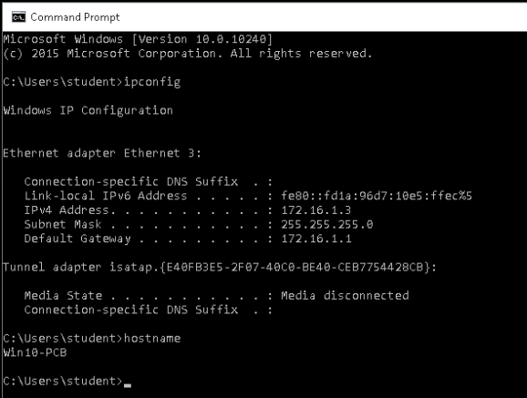
Change IP of Win10B to 172.16.1.3
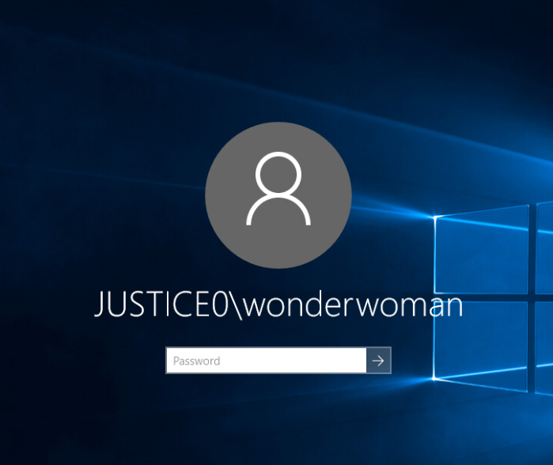
Join the Windows10B computer to the new domain and log on as wonderwoman
Create the following folders with permissions on your domain controller and test
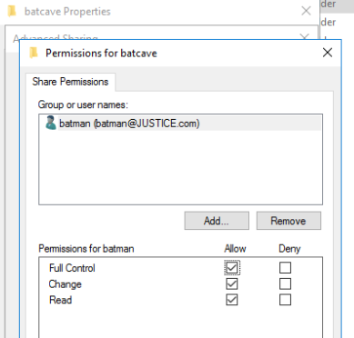
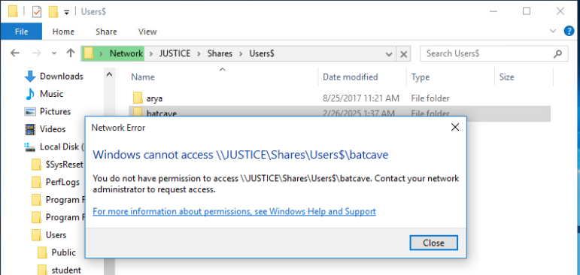
batcave (only batman)
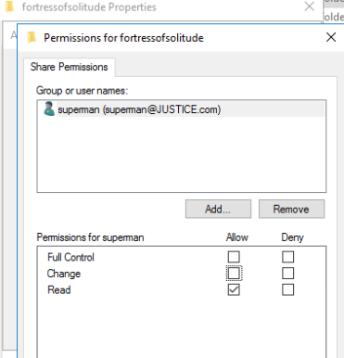
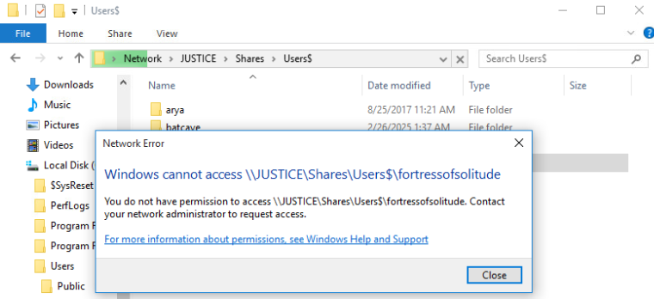
fortresofsolitude (only superman)
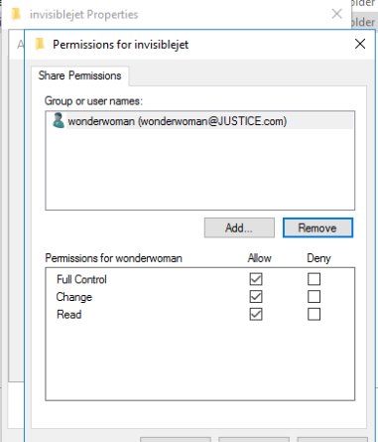
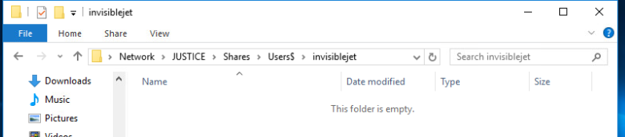
invisiblejet (only wonderwoman)

Part B:
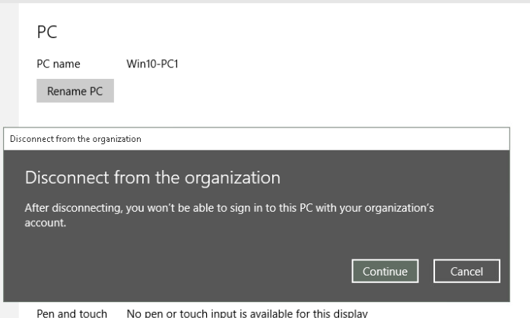
Remove Win10-A (Win10-PC1) from Active Directory
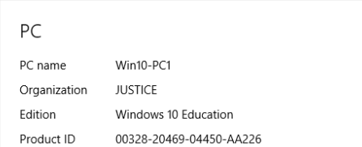
Join Win10-A to the Justice Domain from part A
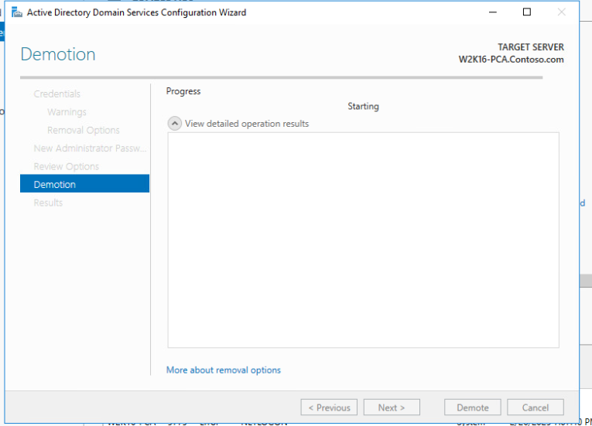
Demote Domain Controller W2K16-DCA
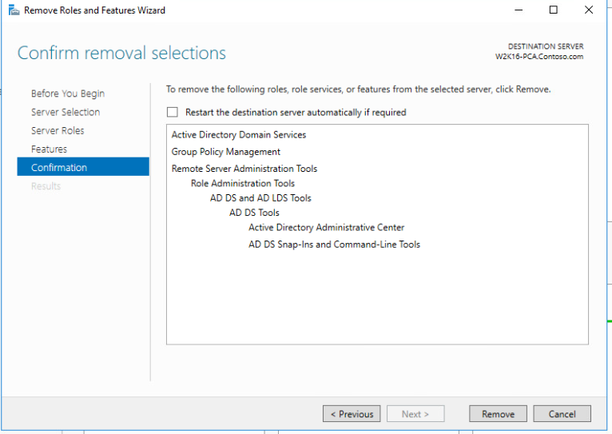
Remove AD role from W2K16-DCA

Join the W2K16-DCA to Justice Domain from part A

Log in to the Win10-A and W2K16-DCA and attempt to access the folders created in part A:

Log in as Batman, Superman, and Wonderwoman and attempt to access your folders

Batman attempt to access

Superman Attempt to access
Wonderwoman attempt to access

Part C: Netlabve2 Linux+ 2 Lab03 for C and DLinks to an external site.

Add the below users to the Ubuntu Server and the CentOS Server (state any differences between the two servers)
ironman
thor
captainamerica
spiderman
thanos
antman
hulk
drstrange
blackpanther
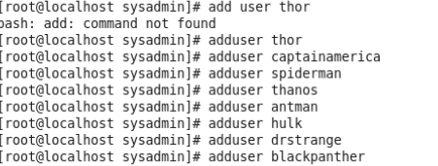
Users added centos (sysadmin had no sudo rights and had to add users to the wheel group for sudo)
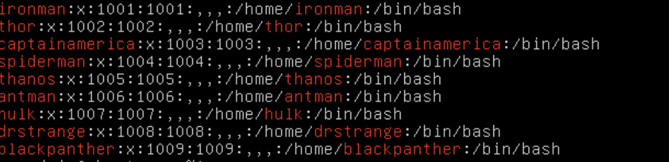
Users added ubuntu

Grant the below users sudo rights
thanos (test this account to ensure that it has sudo rights) (centos)
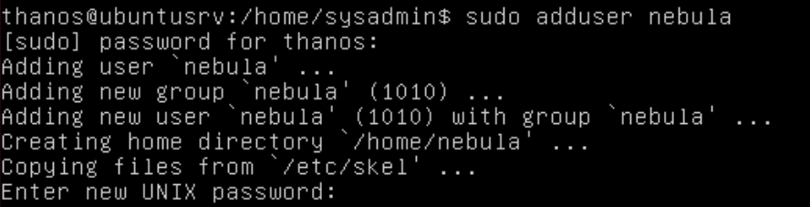
thanos (test this account to ensure that it has sudo rights) (Ubuntu)

as Thanos, add nebula (Centos)
as Thanos, add nebula (Ubuntu)

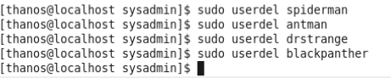
as Thanos, remove spiderman, antman, drstrange, and blackpanther (centos)
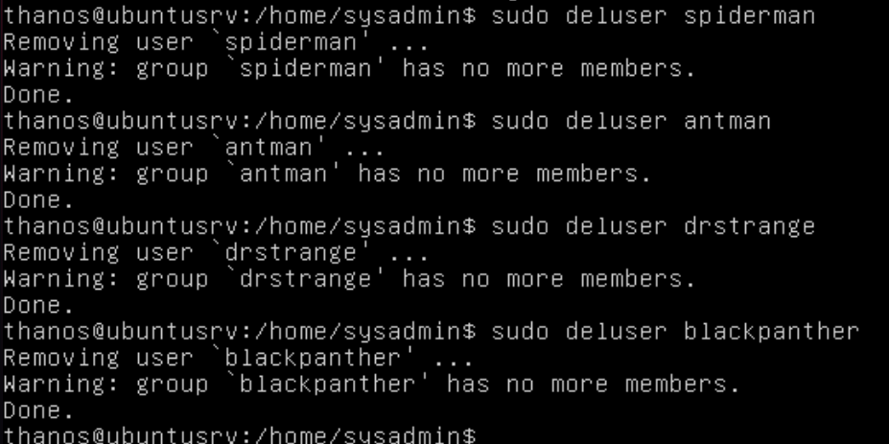as Thanos, remove spiderman, antman, drstrange, and blackpanther (Ubuntu)

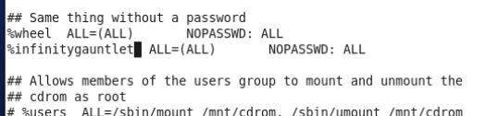
Create a group called infinitygauntlet and add this group to the sudoers file (Centos)
Create a group called infinitygauntlet and add this group to the sudoers file (Ubuntu)

Add the below user to the infinitygauntlet group
Ironman (centos)
Ironman (ubuntu)
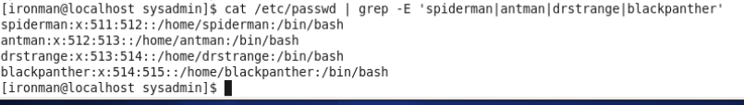
Test ironman's rights by adding the users spiderman, antman, drstrange, and blackpanther (centos)
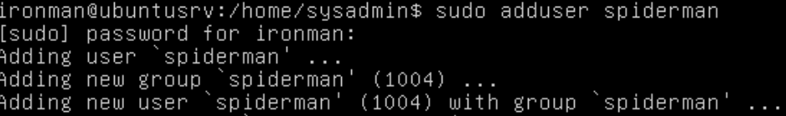
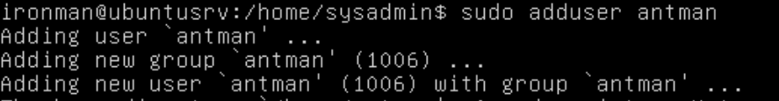
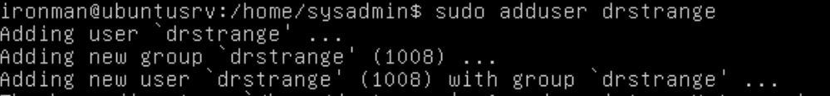
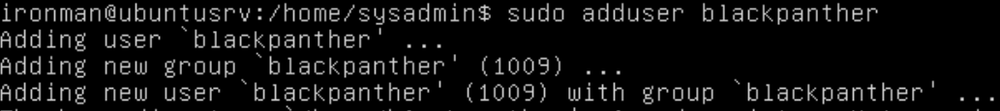
Test ironman's rights by adding the users spiderman, antman, drstrange, and blackpanther (Ubuntu)


Test ironman's rights by deleting thanos (centos)
Test ironman's rights by deleting thanos (Ubuntu)

Part D: See Reference Section for Additional Assistance
On both Ubuntu Server and the CentOS Server:
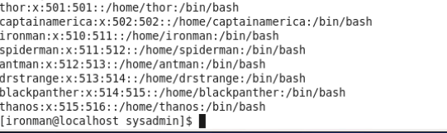
Ensure that the users from part C are added (centos)
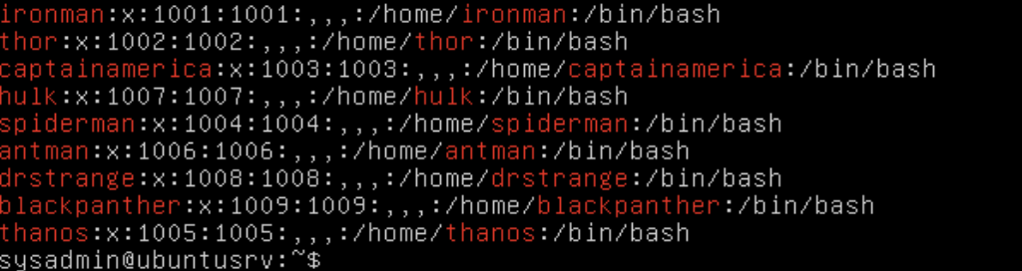
Ensure that the users from part C are added (ubuntu)
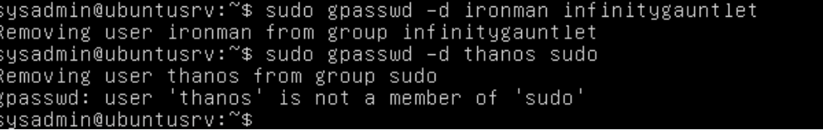

Remove "ALL" rights to all users. Users should all be standard users
(no rights were added to users in the exercise only groups with permissions centos )

Create the below groups

Centos
lowrights
mediumrights
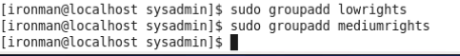
Groups added
Edit the group rights as follows
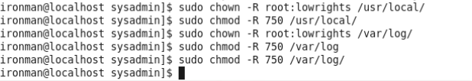
lowrights- run scripts, view all logs
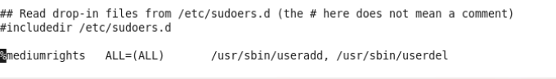
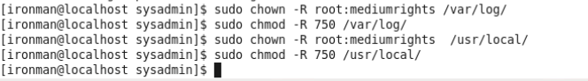
mediumrights- add users, delete users, run scripts, view all logs
Add the below users to the group listed and test their rights
ironman- full sudo rights
thor- full sudo-rights
captainamerica- lowrights
spiderman- lowrights
thanos- lowrights
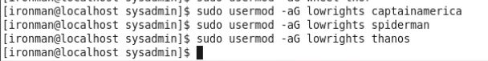
Low rights added
antman- mediumrights
hulk- mediumrights
drstrange- mediumrights
blackpanther- mediumrights
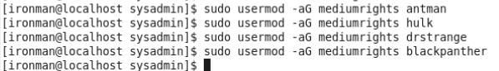
Mediumrights added

Ubuntu

lowrights
mediumrights
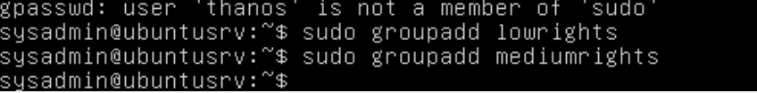
Edit the group rights as follows
lowrights- run scripts, view all logs
mediumrights- add users, delete users, run scripts, view all logs
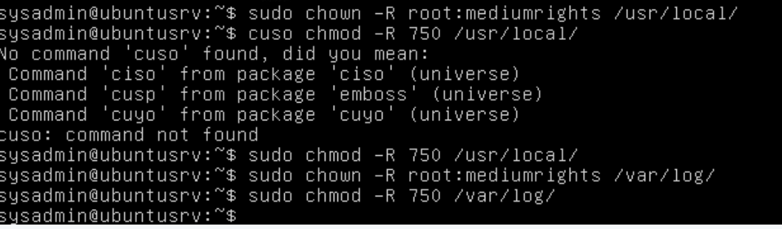
Add the below users to the group listed and test their rights
ironman- full sudo rights
thor- full sudo-rights
captainamerica- lowrights
spiderman- lowrights
thanos- lowrights
antman- mediumrights
hulk- mediumrights
drstrange- mediumrights
blackpanther- mediumrights
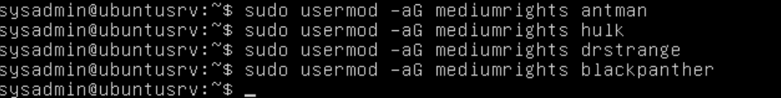

Create the below folders with the below rights and share them accordingly and test. Where is the best place to share them?
Silly Stone (777 to everyone)
Space Stone (755 to everyone)
Reality Stone (RWX to everyone)
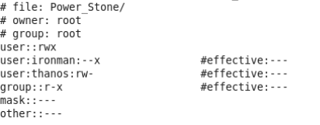
Power Stone (RW to Thanos, X to Ironman)
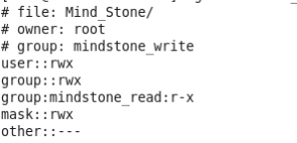
Mind Stone (W to antman, spiderman, hulk. RX to drstrange, blackpanther)
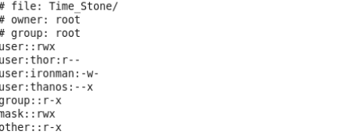
Time Stone (R to Thor, X to Thanos, W to ironman)
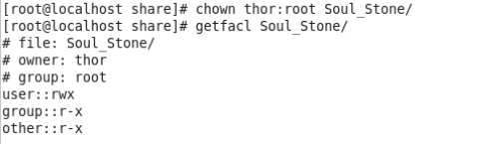
Soul Stone (327 to Thor)
Create the below folders with the below rights and share them with the groups accordingly and test. Where is the best place to share them?
Endgame (700 to lowrights)
Infinity War (755 to mediumrights)
Age of Ultron (RWX to lowrights)
The Dark World (RW to lowrights)
Winter Soldier (W to mediumrights)
Ragnarok (R and X to mediumrights)

